Customer Segmentation and Prediction Using Python

1. Objective
The objective of this project is to analyze customer behavior, segment customers into meaningful groups based on purchasing patterns, and build a predictive model to classify customers into different segments.

2. Dataset Description
The dataset contains customer demographic and behavioral information, including:
- Customer ID
- Age
- Annual Income
- Months Active
- Average Monthly Spend
- Purchase Frequency
- Average Order Value
- Discount Usage Rate
- Return Rate
- Browsing Time Minutes
- Support Interactions
- Payment Method
- Region

3. Data Cleaning
The following data cleaning steps were performed:
- Checked for missing values and handled them appropriately.
- Removed duplicate records.
- Corrected data types where necessary.
- Prepared the dataset for analysis and modeling.

4. Exploratory Data Analysis (EDA)
Several visualizations were created to understand customer behavior:
- Customer Segment Distribution
- Age Distribution
- Annual Income Distribution
- Region Distribution
- Payment Method Distribution
- Correlation Heatmap
Key observations:
- Customers show different spending and purchasing behaviors.
- Income and spending-related features exhibit positive relationships.
- Customer demographics and purchasing patterns vary across regions.
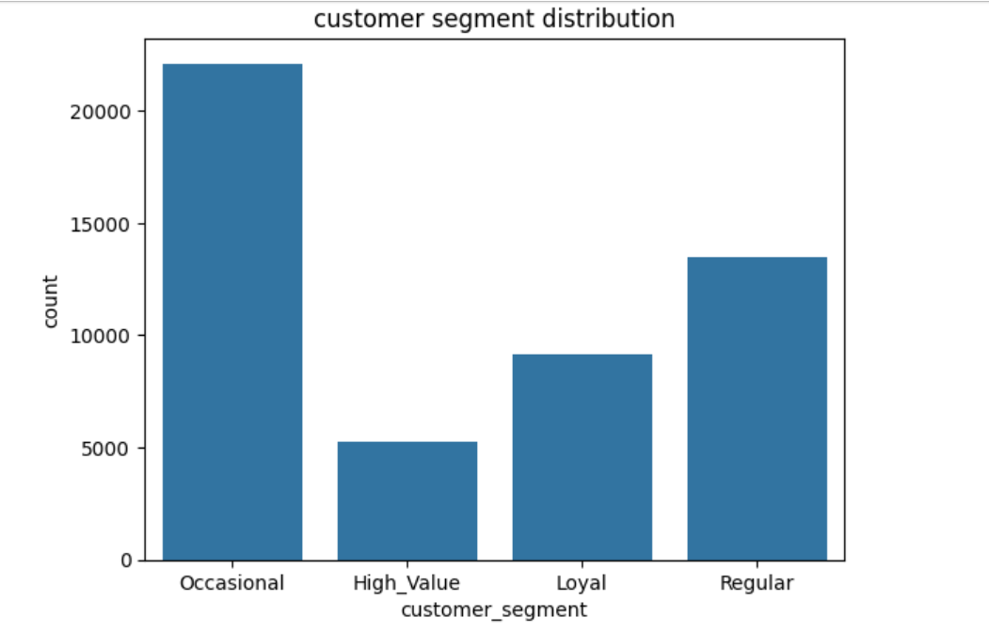

5. Feature Engineering
A new feature, Customer Lifetime Value (CLV), was created using:
CLV = Average Monthly Spend × Months Active
This feature helps estimate the long-term value of each customer.
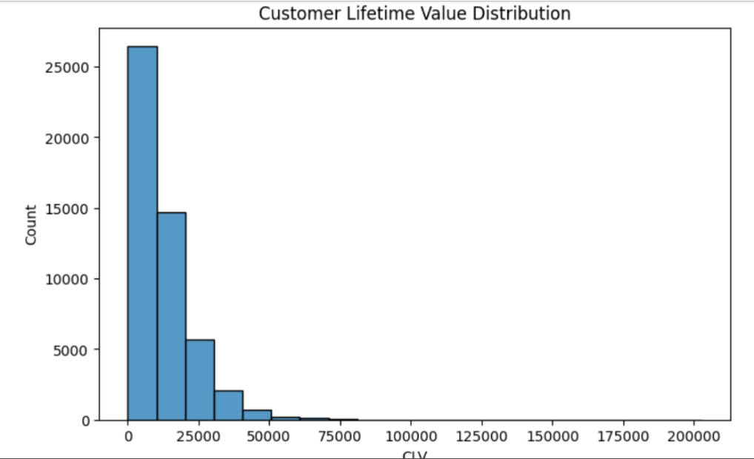

6. Customer Segmentation
K-Means Clustering was applied to segment customers based on:
- Annual Income
- Average Monthly Spend
- Purchase Frequency
- Average Order Value
- Months Active
- Customer Lifetime Value (CLV)
The Elbow Method was used to determine the optimal number of clusters (5).
Customer segments identified:
- High Value Customers
- Loyal Customers
- Frequent Buyers
- Occasional Customers
- High-Income Potential Customers
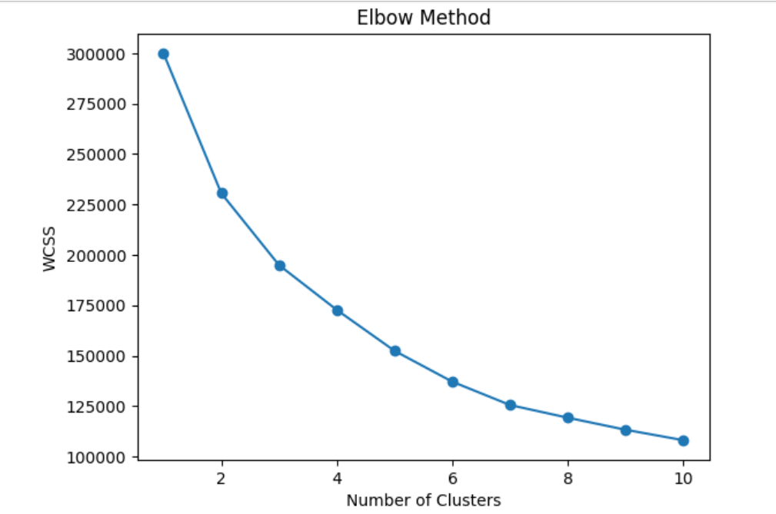

7. Predictive Modeling
A Decision Tree Classifier was developed to predict customer segments using customer behavioral features.
Steps:
- Split data into training and testing datasets.
- Trained the Decision Tree model.
- Generated predictions on unseen data.

8. Model Evaluation
The model was evaluated using:
- Accuracy
- Precision
- Recall
- F1-Score
- Confusion Matrix
The evaluation results indicate that the model can effectively classify customers into their respective segments.

9. Business Insights and Recommendations
High Value Customers:
- Highest spending and CLV.
- Recommendation: VIP offers and premium memberships.
Loyal Customers:
- Long-term customer relationships.
- Recommendation: Loyalty and retention programs.
Frequent Buyers:
- Purchase frequently but spend less per order.
- Recommendation: Cross-selling and bundle offers.
Occasional Customers:
- Lower engagement and spending.
- Recommendation: Re-engagement campaigns and targeted discounts.
High-Income Potential Customers:
- High income but moderate spending.
- Recommendation: Promote premium products and personalized offers.

10. Conclusion
This project successfully applied data analysis and machine learning techniques to segment customers and predict customer behavior. The results provide valuable insights that can support targeted marketing strategies and improve customer retention.

